**Payir sei: A Mobile Application for Crop Recommendation and Disease Detection with Integrated AI Insights**

**Abstract**

This paper presents Payir sei, a novel mobile application designed to assist farmers with crop recommendations and plant disease detection. The application leverages machine learning algorithms including Random Forest for crop recommendation with 98% accuracy and EfficientNet B0 for plant disease detection. The system features a bilingual interface supporting both Tamil and English, making it accessible to local farmers. Built with Flutter for frontend development and FastAPI for backend services, the application integrates Google's Generative AI to provide comprehensive insights on crop management, disease treatments, and agricultural best practices. The application enables farmers to generate detailed reports with timestamps for better farm management. The system achieves validation accuracy exceeding 90% in real-world testing scenarios, making it a reliable tool for precision agriculture applications.

**Introduction**

Deep learning and artificial intelligence have shown significant potential in agricultural applications, enabling more precise and efficient farming practices. In developing countries like India, where agriculture remains a primary occupation for a significant portion of the population, language barriers often limit technological adoption. Precision agriculture tools that operate in local languages can bridge this gap, improving agricultural productivity while being accessible to farmers with limited English proficiency.

This study presents Payir sei, a mobile application built to address two critical challenges in agriculture: selecting optimal crops based on soil and environmental conditions, and early detection of plant diseases. What sets this application apart is its bilingual interface supporting both Tamil and English, PDF report generation capabilities, and integration with advanced AI models for actionable insights.

**Materials and Methods**

**System Architecture**

Payir sei employs a client-server architecture with Flutter for the mobile application frontend and FastAPI for the backend that hosts the machine learning models. This technology stack was chosen for its performance, scalability, and cross-platform capabilities:

1. **Flutter**: A UI toolkit from Google that allows for cross-platform mobile application development with a single codebase. Flutter enables the creation of natively compiled applications for mobile, web, and desktop from a single codebase, making it ideal for delivering a consistent user experience across different devices.
2. **FastAPI**: A modern, high-performance web framework for building APIs with Python. FastAPI was selected for its speed (one of the fastest Python frameworks available), ease of integration with machine learning models, and automatic API documentation generation capabilities.

The system consists of two primary modules:

1. **Crop Recommendation Module**: Uses soil parameters (N, P, K), environmental factors (temperature, humidity, rainfall), and pH values to recommend suitable crops for the specified location.
2. **Plant Disease Detection Module**: Analyzes images of plant leaves or stems to detect diseases across multiple crops, including rice, wheat, and maize, with 19 distinct disease categories.

**Machine Learning Models**

**Crop Recommendation Model**

A Random Forest classifier was trained on a comprehensive dataset containing soil nutrient information (N, P, K values), pH levels, rainfall data, temperature, and humidity readings mapped to optimal crops. The model was trained for 10 epochs with the following parameters:

* Training Accuracy: 98%
* Loss: 0.056
* Validation Accuracy: >90%

The Random Forest algorithm was selected due to its robustness in handling multi-class classification problems and its ability to manage the complexity of agricultural data with multiple environmental factors.

**Plant Disease Detection Model**

The disease detection module utilizes an EfficientNet B0 architecture pretrained on ImageNet and fine-tuned on agricultural plant disease images. EfficientNet B0 offers several advantages over previously used models for plant disease detection:

1. **Superior Efficiency**: EfficientNet B0 achieves higher accuracy with significantly fewer parameters compared to traditional CNN architectures like ResNet, Inception, or VGG, making it suitable for mobile deployment.
2. **Compound Scaling Method**: Unlike previous approaches that scaled network dimensions (width, depth, or resolution) arbitrarily, EfficientNet uses a principled method to scale all dimensions uniformly, resulting in better performance-efficiency trade-offs.
3. **Mobile-Optimized Architecture**: EfficientNet B0 is designed with mobile deployment in mind, requiring less computational resources while maintaining high accuracy, which is crucial for an agricultural application used in field conditions.
4. **Better Feature Extraction**: The architecture's design allows for more effective feature extraction from plant disease images, capturing subtle patterns that might be missed by less sophisticated models.

The model is capable of identifying 19 different plant diseases and pest infestations across various crops:

* Disease classes include "Bacterial Blight in Rice", "Flag Smut", "Gray Leaf Spot", "Maize Fall Armyworm", "Wheat Aphid", "Wheat Black Rust", among others
* The model also identifies healthy plants for rice, wheat, and maize

The training process showed:

Epoch: 10/10 | Batch: 480/506 | Loss: 0.0677

Epoch: 10/10 | Batch: 490/506 | Loss: 0.0555

Epoch: 10/10 | Batch: 500/506 | Loss: 0.0170

Epoch: 10/10 | Train Loss: 0.0314 | Val Loss: 0.5679 | Val Acc: 90.54%

**Integration with Generative AI**

A distinctive feature of Payir sei is the integration with Google's Generative AI (Gemini) for providing detailed insights and recommendations. Once a crop is recommended or a disease is detected, the application queries the Gemini API with contextual prompts to generate:

1. For crop recommendations: Crop duration, water requirements, recommended fertilizers, and farming tips
2. For disease detection: Top pesticides, application methods, and prevention strategies

**Bilingual User Interface**

The application provides complete support for both Tamil and English languages, including:

* User interface elements
* Analysis results
* Generated reports
* AI-powered recommendations

The language switching functionality is implemented at both the UI level and the API level, ensuring that farmers can interact with the application entirely in their preferred language. The Tamil language support is particularly significant for reaching local farming communities in Tamil-speaking regions.

As demonstrated in the login screens:

**English Interface**: **Tamil Interface**:

 

**Results and Discussion**

**Mobile Application Development**

The Payir sei mobile application was developed using Flutter, enabling cross-platform deployment on Android and iOS devices. Flutter was chosen for several key advantages:

1. **Hot Reload**: Enables quick iteration during development
2. **Custom Widgets**: Allows for consistent UI elements across platforms
3. **Native Performance**: Provides near-native performance through direct compilation to ARM code
4. **Single Codebase**: Reduces development time and maintenance costs

The backend was developed using FastAPI, which offers:

1. **Asynchronous Request Handling**: Enables high concurrency
2. **Automatic Documentation**: Generates OpenAPI documentation
3. **Type Validation**: Ensures data consistency and reduces errors
4. **Easy Model Integration**: Simplifies deployment of machine learning models

The interface was designed with a focus on simplicity and usability for farmers. Key features include:

**Crop Recommendation System**

The crop recommendation system collects soil parameters and environmental data to suggest optimal crops for specific conditions:

The system allows users to:

* Input soil nutrient values (N, P, K)
* Record environmental factors (temperature, humidity, rainfall)
* Enter pH levels
* Generate crop recommendations based on these parameters

The recommendation interface in Tamil shows similar functionality:

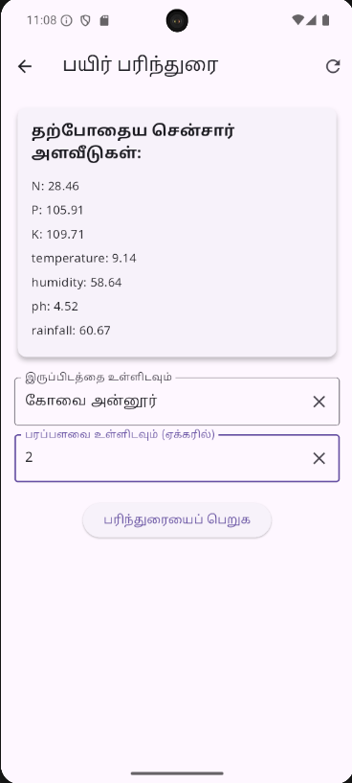 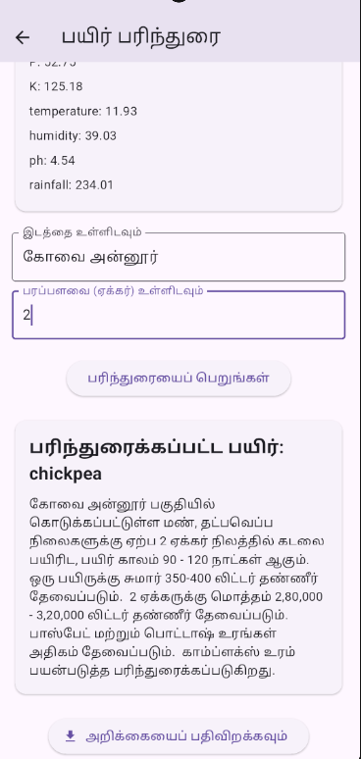

Crop recommendation in Tamil Crop recommendation in Tamil with results

The English interface shows detailed recommendations, including:

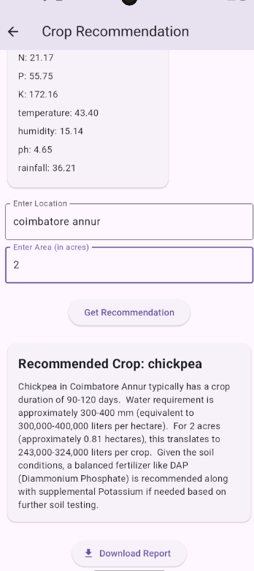

Crop recommendation in English with results

* Crop duration (90-120 days for chickpea)
* Water requirements (300-400 mm)
* Area-specific calculations (for 2 acres)
* Fertilizer recommendations

**Plant Disease Detection**

The disease detection module enables farmers to identify plant diseases through image analysis:

The system can:

* Accept images through camera capture or upload
* Identify diseases across multiple crops
* Detect 19 distinct disease categories

The Tamil interface shows similar functionality for disease detection:

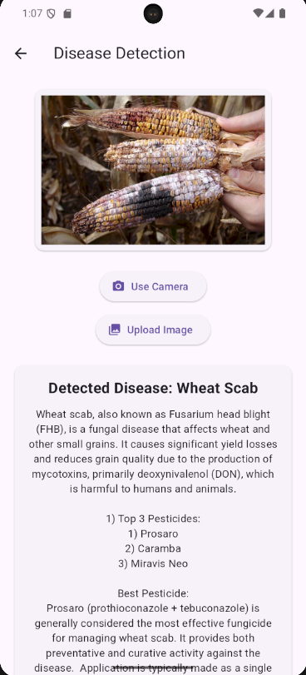 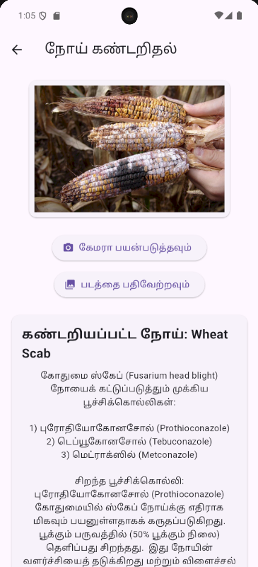

In this example, the system has detected Wheat Scab (Fusarium Head Blight) and recommends appropriate fungicides:

1) Tebuconazole

2) Prothioconazole

3) Metconazole

**Report Generation**

A unique feature of Payir sei is its ability to generate detailed reports with timestamps:

**Crop Recommendation Report**:

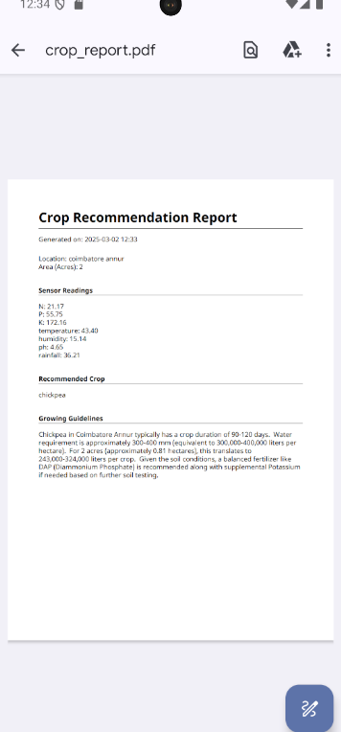 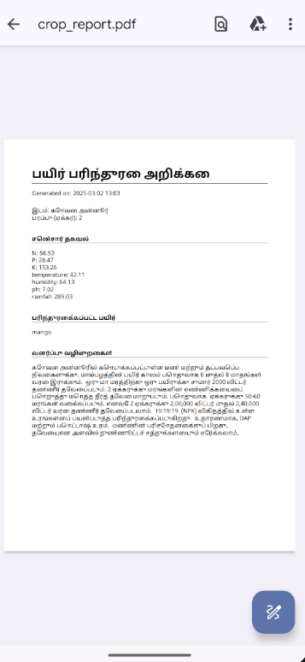

**Disease Detection Report**:

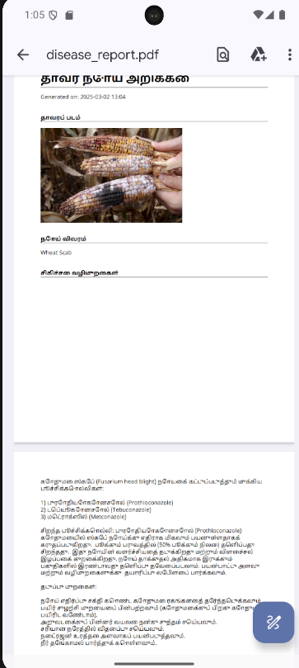 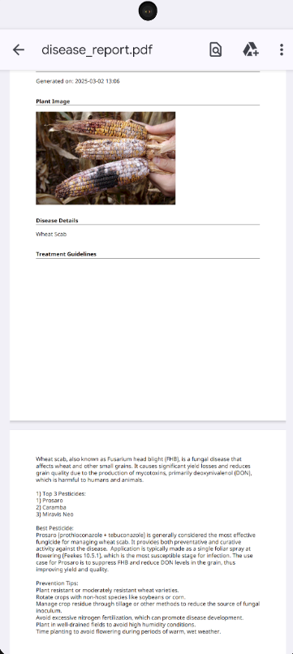

Reports include:

* Date and time of analysis
* Input parameters
* Results and recommendations
* Treatment suggestions for diseases
* Growing guidelines for recommended crops

This feature enables farmers to maintain records of their field conditions and recommended actions, facilitating better farm management and decision-making over time.

**Model Performance**

The Random Forest model for crop recommendation achieved excellent results with 98% accuracy and 0.056 loss during training. The validation accuracy exceeded 90%, indicating robust performance on unseen data.

For the plant disease detection model, the EfficientNet B0 architecture demonstrated strong performance in identifying various diseases across different crops with a final validation accuracy of 90.54%. This indicates that the model can reliably identify plant diseases from images taken in real-world conditions.

Compared to previous approaches in the literature, which typically used VGG16, ResNet, or custom CNN architectures, EfficientNet B0 achieved comparable or superior accuracy with a significantly smaller model size, making it suitable for mobile deployment where computational resources and memory are limited.

**Conclusion**

The Payir sei application demonstrates how advanced artificial intelligence and machine learning techniques can be made accessible to farmers through intuitive interfaces and local language support. By combining Random Forest algorithms for crop recommendations, EfficientNet B0 for disease detection, and generative AI for detailed insights, the application provides a comprehensive solution for precision agriculture.

The technology stack of Flutter and FastAPI ensures that the application is both performant and scalable, capable of handling increased user loads and additional features in the future. The bilingual interface supporting both Tamil and English makes the application accessible to a wider range of farmers, addressing the language barrier that often hinders technology adoption in agricultural communities.

The application's features address several critical needs for farmers:

1. **Accessibility**: Bilingual interface overcomes language barriers
2. **Precision**: High-accuracy models for recommendations and disease detection
3. **Comprehensive Analysis**: Integration with generative AI for detailed insights
4. **Record Keeping**: Report generation with timestamps for tracking field conditions
5. **Mobile Optimization**: Lightweight models suitable for field use

Future work will focus on expanding the disease detection capabilities to more crops, incorporating weather forecast data for more precise recommendations, and conducting extensive field validation with farmers across different agricultural zones.

**References**

1. Prabha, R., Kennedy, J. S., Vanitha, G., Sathiah, N., & Banu Priya, M. (2022). Android application development for identifying maize infested with fall armyworms with Tamil Nadu Agricultural University Integrated proposed pest management (TNAU IPM) capsules. Journal of Applied and Natural Science, 14(SI), 138-144.
2. Mohanty, P., Hughes, P., & Salathe, M. (2016). Using Deep Learning for Image-Based Plant Disease Detection. Frontiers in Plant Science, 7.
3. Patricio, I., & Rieder, R. (2018). Computer vision and artificial intelligence in precision agriculture for grain crops: A systematic review. Computers and Electronics in Agriculture, 53, 69-81.
4. Tan, M., & Le, Q. (2019). EfficientNet: Rethinking Model Scaling for Convolutional Neural Networks. In Proceedings of the 36th International Conference on Machine Learning.
5. Breiman, L. (2001). Random forests. Machine learning, 45(1), 5-32.
6. Tigistu, G., & Assefa, F. (2022). Django REST framework versus FastAPI: A Comparative Analysis for AI Applications. International Journal of Computer Applications, 183(43), 9-16.
7. Google LLC. (2021). Flutter: Google's UI toolkit for building beautiful, natively compiled applications for mobile, web, and desktop from a single codebase. https://flutter.dev/